Anchors Away Parent Bulletin
Week of Monday, November 2, 2015

PROFICIENCY, POSITIVE RELATIONSHIPS, & PILOT PRIDE

- UPCOMING EVENTS AT FCEMS
- November 2 – Nutritional Program for 4th Grade at 9:00 (Fulton City 4th Graders are joining us too.)
- November 2 – FCMS vs. Black Oak HOME (Date Changed from Nov. 3rd)
- November 3 – No School: Election Day
- November 5 – Academic Meet at FCMS
- November 5 – Picture Forms and Money are Due in to the School
- November 9 – FCMS vs. Hickman County AWAY
- November 9 – Health Fair for Grades K-5th
- November 10 – Progress Reports Go Home
- November 10 – Academic Meet at Fulton City
- November 11 – Veteran’s Day Program at 1:30 in the FCEMS Gym
- November 12 – FCMS vs CCA AWAY
- November 14 – Miss FCHS
- November 16 – Career Fair Grades 5-8 from 8:30-12:00
- November 17 – Academic Meet at Hickman County
- November 17 – FCMS vs. Carlisle HOME
- November 19 – School Board Meeting in FCEMS Library
- November 23 – Science Fair
- November 24 – Science Fair Awards Program at 2:00 in Gym
- November 25-27 – Thanksgiving Break
- November 30 – FCHS vs. Trigg/Murray HOME

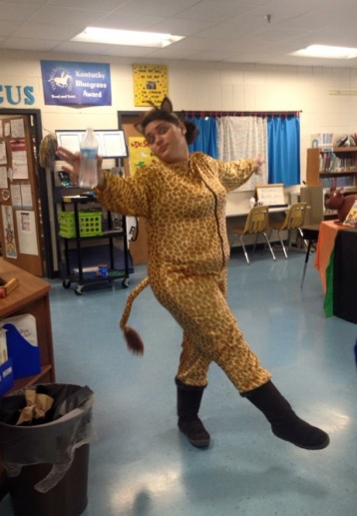

- THANKS SO MUCH!!!!
A BIG THANKS goes out to Ms. Stephanie Mora for all of her hard work and dedication in preparing our students for the Halloween Musical! The musical was once again a HUGE SUCCESS!

- FLU SHOTS
The Purchase District Health Department will be giving FLU SHOTS at the school on November 9th and 19th for those who have turned in their paperwork.

- ACADEMIC TEAM SCHEDULE

DATE | HOST (TEAM 1) | TEAM 2 | TEAM 3
Thursday, Nov. 5 | Fulton County | Hickman County
Tuesday, Nov. 10 | Fulton City | Fulton County | Carlisle County
Tuesday, Nov. 17 | Hickman County | Fulton County

- CROSS COUNTRY TEAM
Congratulations to the FCHS Cross Country Team for qualifying to go to STATE! Our very own 8th grader, Marlena Sipes placed 3rd at the meet! We are super proud of all of her accomplishments this year. Hunter Terrell, 7th grader, also ran with the high school team. He was our overall 5th finisher. His time helped our Boys’ Team snag the 1st Place trophy!! Our girls were Runner-Ups at the Regional Finals. Both teams will head to Lexington this weekend for the state competition.
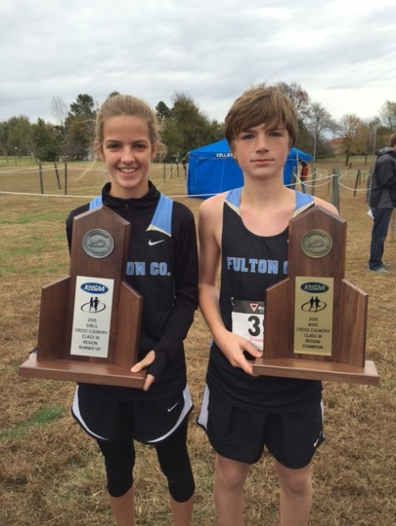
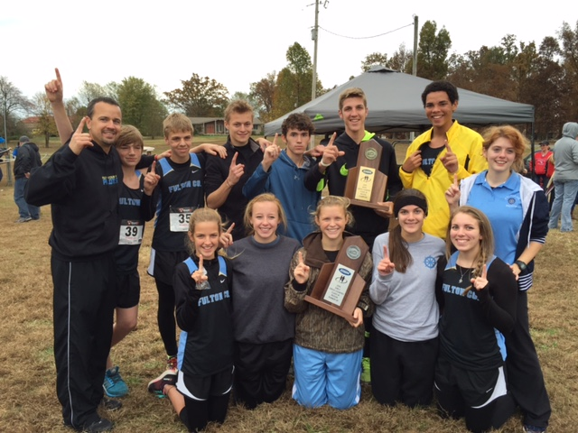

- HALLOWEEN CELEBRATIONS
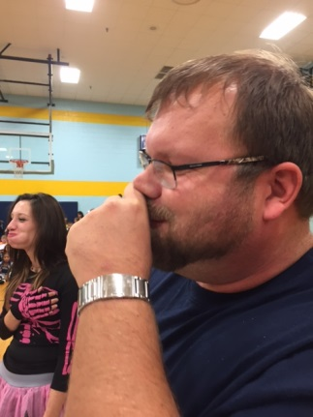
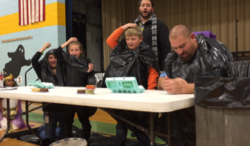
Our students did an AWESOME job at our Halloween Musical on Friday. We want to thank all of our parents who stepped up and helped in our celebration time. Thanks for all the laughs and for just having fun with the kids!!
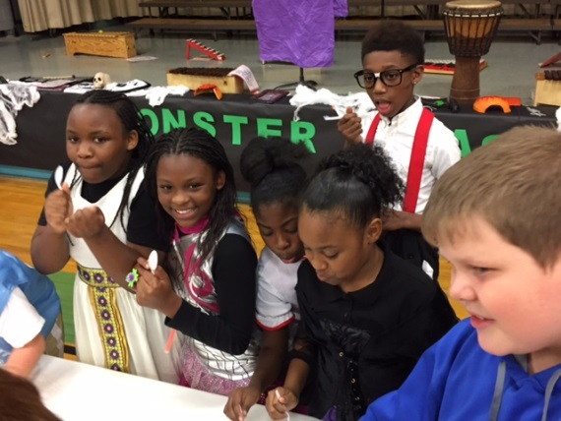
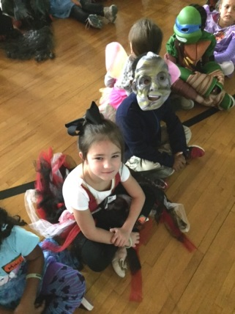
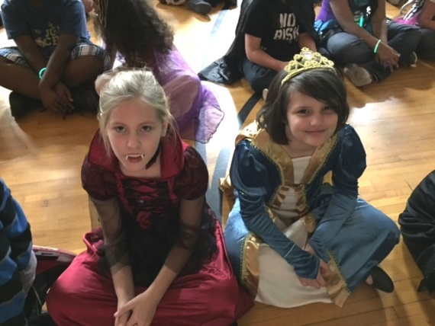
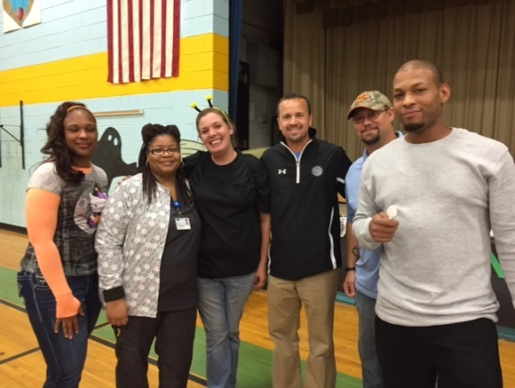

Fulton County Athletics

DATE SPORT RIVAL LOCATION/TIME CONCESSIONS
Tue 11/02 MS B 7b8g8b BlackOak@Hornbeak HOME @ 5:00 GOLF & HS CHEER
Mon 11/09 MS B 7b8g8b Hickman Co Away @ 5:00 --
Thu 11/12 MS B 8g8b CCA Away @ 5:00 --
Tue 11/17 MS B 7b8g8b Carlisle Co HOME @ 5:00 HS GIRLS BBALL
Mon 11/30 HS B GV Trigg Co HOME @ 6:00 MS CHEER *
Mon 11/30 HS B BV Murray HOME @ 7:30 MS CHEER *
Tue 12/01 HS B GV/BV Joppa, IL Away @ 6:00 --
Thu 12/03 MS B 7b8g8b Fulton City Away @ 5:00 --
Mon 12/07 HS B GV/BV Peabody, Trenton, TN Away @ 6:00 --
Thu 12/10 HS B GV/BV Marshall Co Away @ 6:00 --
Sat 12/12 MS B 8g8b Lake Co, TN HOME @ 3:00 HS TRACK
Sat 12/12 HS B GV/BV Lake Co, TN HOME @ 6:00 MS TRACK
Mon 12/14 MS B 7b8b Reidland Away @ 5:00 --
Tue 12/15 HS B BJV/BV Calloway Co Away @ 6:00 --
12/17 – 12/21 HS B BV Chr Fellowship Tourny TBA
Tue 12/29 HS B GV Trigg New Years Tourny TBA
Mon 1/04 MS B 7g8g8b Carlisle Co Away @ 5:00 --
Tue 1/05 HS B BJV/GV/BV Hickman Co Away @ 5:00 --
Thu 1/07 MS B 7b8b Reidland HOME @ 5:00 HS FOOTBALL
Fri 1/08 HS B GV/BV Fulton City Away @ 6:00 --
Sat 1/09 HS B GV/BV Marshall Co HOME @ 6:00 MS FOOTBALL
Mon 1/11 MS B 7g8g8b Hickman Co(8th Gr Night) HOME @ 5:00 VOLLEYBALL
Tue 1/12 HS B BJV/BV McCracken Co HOME @ 6:00 SOFTBALL
Fri 1/15 HS B BJV/GV/BV Carlisle Co Away @ 5:00 --
1/16 – 1/23 HS B GV/BV 1st Region All ‘A’ Classic TBA
Tue 1/19 MS B 7g8g8b Fulton City HOME @ 5:00 BASEBALL
Thu 1/21 MS B 7g8g8b BlackOak@Hornbeak Away @ 5:00 --
Mon 1/25 HS B BJV/GV/BV Mayfield Away @ 5:00 --
Thu 1/28 HS B GV/BV Ballard Memorial Away @ 6:00 --
Fri 1/29 HS B GV/BV CCA* HOME @ 6:00 MS GIRLS BBALL
Tue 2/02 HS B BJV/GV/BV Carlisle Co HOME @ 5:00 MS BOYS BBALL
Fri 2/05 HS B BJV/GV/BV Hickman Co HOME @ 4:30 MS CHEER

Sat 2/06 HS B GV/BV Lake Co, TN Away @ 6:00 --
Tue 2/09 HS B GV/BV CFS HOME @ 6:00 MS TRACK
Fri 2/12 HS B GV/BV Fulton City HOME @ 6:00 GOLF & CROSS COUNTRY
Mon 2/15 HS B GV/BV Mayfield HOME @ 6:00 MS FOOTBALL
Thu 2/18 HS B GV/BV Ballard Memorial HOME @ 6:00 SOFTBALL
Fri 2/19 HS B GV/BV Graves Co Away @ 6:00 --
2/22 – 2/26 HS B GV/BV 1st District Tourny TBA

-Picture Money is due to the school by November 5th!
-Progress Reports will come home on Tuesday, November 10th!
-Veteran’s Day Program will be on Wednesday, November 11th!

Fulton County Elementary/Middle School
will focus students on educational success by teaching them to cooperate,
accept responsibility, respect others, expect excellence, and
become life-long learners.

FCEMS CARES!

