Anchors Away Parent Bulletin
Week of Monday, December 14, 2015

PROFICIENCY, POSITIVE RELATIONSHIPS, & PILOT PRIDE

- UPCOMING EVENTS AT FCEMS
- December 14 – FCMS Boys vs. Reidland AWAY
- December 15 – FCHS Boys vs. Calloway AWAY
- December 15 – FCHS Girls vs. Cario AWAY
- December 17 – School Board Meeting at 6:00 p.m. at the Board Office
- December 17 – Rudolph Reader’s at noon in the Gym for Kindergarten – 4th Grade!
- December 17 – Ugly Christmas Sweater Day
- December 18 – 2nd Annual Staff Talent Show starting at 9:00 in the Gym
- December 18 – Christmas Musical at 1:45 in the Gym
- December 19 – Basketball Camp
- December 21-January 1 – Christmas Break
- January 2 – Basketball Camp
- January 4 – FCMS vs. Carlisle County AWAY
- January 5 – FCHS vs. Hickman County AWAY
- January 5 – Report Cards go Home
- January 7 – FCMS Boys vs. Reidland HOME
- January 8 – FCHS vs Fulton AWAY
- January 9 – FCHS vs. Marshall HOME
- January 9 – Basketball Camp
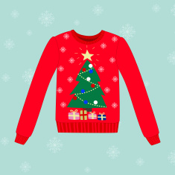

- THANKS SO MUCH!!!!
A BIG THANKS goes out to our Basketball Coaches for organizing our Basketball Camps. An EXTRA BIG THANKS to Mr. Chuck and Mrs. Ellen Murphy for heading up this program in our schools.
Another BIG THANKS goes out to Mrs. Brenda Mahan and Mrs. Tiffany Ray for helping our students prepare for the Lego League Competition this past Saturday. We appreciate all you both do for our students!!!

- UGLY CHRISTMAS SWEATER DAY
FCEMS will dress up in their UGLY CHRISTMAS SWEATERS on Thursday, December 17th.

- ATTENDANCE
During this holiday season, we want you to know how thankful we are for your children! We want to express our gratitude for everyone who makes it possible for as many students to come to school every day, on time, ready to learn. We are thankful for:
• Our students and families for making daily attendance a priority since they know the habit of attendance will help them do well in the classroom and eventually in a job.
• Our wonderful teachers who pour their energy into making each classroom an exciting place for exploration and knowledge so children do not want to miss out on learning
• Our support staff and community volunteers who provide the extra hands and attention our children need. We appreciate each one of you so much. We look forward to seeing you after the Christmas holiday. We also hope you will keep in mind that school will be closed December 21st through January 1st. School will reopen on January 4th. We especially appreciate everyone’s efforts to avoid taking extra days off during the Christmas holiday. Just a few missed days here and there, even if they’re excused absences, can add up to too much lost learning time and leave your child behind in school. This is as true in kindergarten as it is in high school.

- LEGO LEAGUE TEAM
Our Lego League Team placed 1st on their project at Saturday’s Competition. Go PILOTS!!! Students on the team include the following: John Davis Swain, Mason Russom, Caleb Collins, Hailee Edgin, Mia Amberg, Cory Smith, Anna Grace Johnson, and Callie Coulson. Tanner Williams is not pictured.

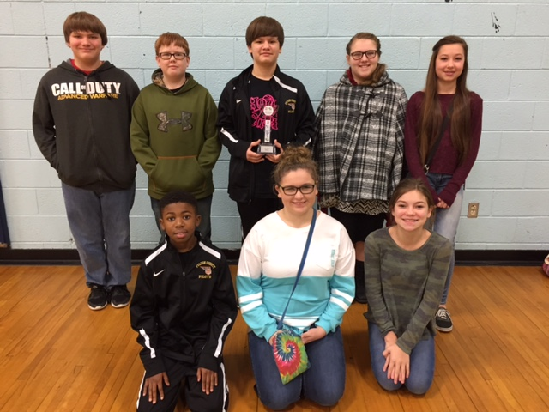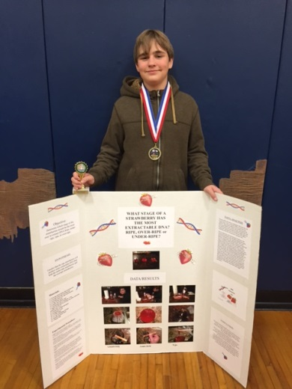
Overall Science Fair Winner
Lego League Team

- SCIENCE FAIR PROJECTS
 | 1st Place | 2nd Place | 3rd Place
Kindergarten | Noah Kilpatrick
1st Grade | Miriam Varden | Jadyn Hatcher
2nd Grade | Emmarie Cermak | Cooper Scott | Chloe McClure
3rd Grade | Hannah Murphy | Landon Cole | Braxton Bridges, Jahamal Cheirs, and Cody Stewart
4th Grade | Tristen Wilson & Madison Forrest | Ben Roberts & Daniel Collins | Connor O’Malley
5th Grade | Luke Jackson | Rex Westbrook | Ky’Aira Couch
6th Grade | Kayleigh Thomas | Arkeishia Smith | Jakyla Crumble, DeAyria Kinney, and Cashayah McClerkin
7th Grade | Will Jackson | Broc Bridges | Remington Stewart
8th Grade | Retiazsha Chambers | Marlena Sipes | Madison Halstead  Aurora Piercefield
Primary Winners | Miriam Varden | Emmarie Cermak  Jadyn Hatcher | Cooper Scott
Intermediate Winners | Luke Jackson | Tristen Wilson & Madison Forrest | Hannah Murphy
Middle School Winners | Will Jackson  Retiazsha Chambers | Marlena Sipes | Madison Halstead  Aurora Piercefield
Overall Science Fair Winner | CALEB FIELDS

Fulton County Athletics

DATE SPORT RIVAL LOCATION/TIME CONCESSIONS
Mon 12/14 MS B 7b8b Reidland Away @ 5:00 --
Tue 12/15 HS B BJV/BV Calloway Co Away @ 6:00 --
12/17 – 12/21 HS B BV Chr Fellowship Tourny TBA
Tue 12/29 HS B GV Trigg New Years Tourny TBA
Mon 1/04 MS B 7g8g8b Carlisle Co Away @ 5:00 --
Tue 1/05 HS B BJV/GV/BV Hickman Co Away @ 5:00 --
Thu 1/07 MS B 7b8b Reidland HOME @ 5:00 HS FOOTBALL
Fri 1/08 HS B GV/BV Fulton City Away @ 6:00 --
Sat 1/09 HS B GV/BV Marshall Co HOME @ 6:00 MS FOOTBALL
Mon 1/11 MS B 7g8g8b Hickman Co(8th Gr Night) HOME @ 5:00 VOLLEYBALL
Tue 1/12 HS B BJV/BV McCracken Co HOME @ 6:00 SOFTBALL
Fri 1/15 HS B BJV/GV/BV Carlisle Co Away @ 5:00 --
1/16 – 1/23 HS B GV/BV 1st Region All ‘A’ Classic TBA
Tue 1/19 MS B 7g8g8b Fulton City HOME @ 5:00 BASEBALL
Thu 1/21 MS B 7g8g8b BlackOak@Hornbeak Away @ 5:00 --
Mon 1/25 HS B BJV/GV/BV Mayfield Away @ 5:00 --
Thu 1/28 HS B GV/BV Ballard Memorial Away @ 6:00 --
Fri 1/29 HS B GV/BV CCA* HOME @ 6:00 MS GIRLS BBALL
Tue 2/02 HS B BJV/GV/BV Carlisle Co HOME @ 5:00 MS BOYS BBALL
Fri 2/05 HS B BJV/GV/BV Hickman Co HOME @ 4:30 MS CHEER
Sat 2/06 HS B GV/BV Lake Co, TN Away @ 6:00 --
Tue 2/09 HS B GV/BV CFS HOME @ 6:00 MS TRACK
Fri 2/12 HS B GV/BV Fulton City HOME @ 6:00 GOLF & CROSS COUNTRY
Mon 2/15 HS B GV/BV Mayfield HOME @ 6:00 MS FOOTBALL
Thu 2/18 HS B GV/BV Ballard Memorial HOME @ 6:00 SOFTBALL
Fri 2/19 HS B GV/BV Graves Co Away @ 6:00 --
2/22 – 2/26 HS B GV/BV 1st District Tourny TBA

Fulton County Elementary/Middle School
will focus students on educational success by teaching them to cooperate,
accept responsibility, respect others, expect excellence, and
become life-long learners.

FCEMS CARES!

