Anchors Aweigh Parent Bulletin
Week of Monday, November 7, 2016

PROFICIENCY, POSITIVE RELATIONSHIPS, & PILOT PRIDE

- FULL STEAM AHEAD . . . UPCOMING EVENTS
- November 7 – Learning Checks and Pizza Party at 2:00 for the Grade Level that wins the Penny War
- November 7 – FCMS BB vs. Hickman County (Home)
- November 8 – NO SCHOOL – ELECTION DAY
- November 9 – SBDM at 3:30
- November 10 – FCMS BB vs. Lake County (Home)
- November 10 – Academic Meet at Carlisle County
- November 11 – Veterans Day Program
- November 11 – Booster Club Fall Festival
- November 14 – Parent-Teacher Conferences 3:30-6:30 (Parent Sharpen the Saw Activities and PTSO at 5:30)
- November 15 – FCMS BB vs. Carlisle (Home)
- November 17 – FCMS BB vs. Union City (Home)
- November 19 – Miss FCHS
- November 21-22 – Science Fair
- November 23-25 – NO SCHOOL: Thanksgiving Break
- November 29 – FCMS vs. Lake County (Away)
- November 29 – Academic Meet at Carlisle County
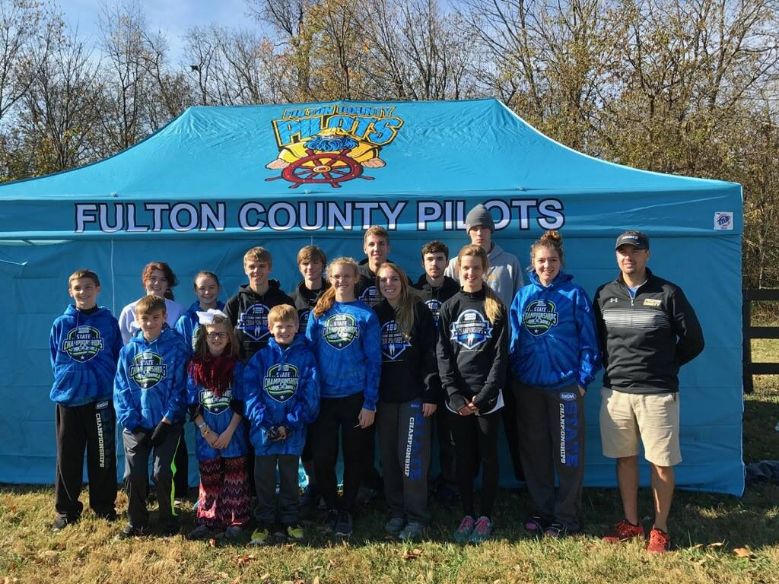
To our Fulton County CROSS COUNTRY TEAM
For a JOB WELL DONE at the STATE MEET!

- PARENT POWER HOUR
A BIG THANKS to all the parents that came out for our Parent Power Hour on Friday. We appreciate all of you giving of your time for our students. It is so great to get everyone’s input to help our students!

- PTSO PENNY WARS
Our students raised over $619.00 for our Playground Equipment. The classroom winner will be announced on Monday and will have a PIZZA PARTY in the Library at 2:00. We appreciate all our parents and grandparents sending in those pennies! GREAT JOB FCEMS!!

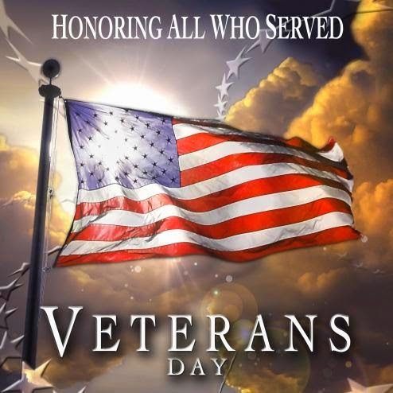

- VETERANS DAY PROGRAM
Please join us on Friday, November 11th for our annual Veterans Day Program
in the FCEMS Gymnasium. All veterans will be recognized and honored as our students show appreciation to all who have served. If you know a Veteran who would like to join us, please invite them to this special program.

- BOOSTER CLUB FASS FESTIVAL
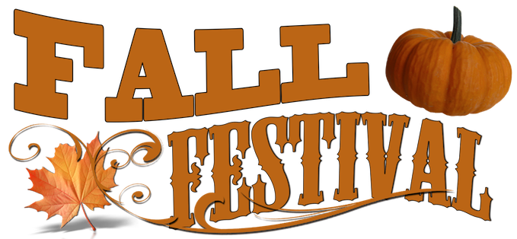
The Fulton County Athletic Booster Club is sponsoring a Fall Festival on November 11, 2016 from 6pm to 9pm in the Fulton County Elementary/Middle School Gym. We will have family friendly games for the students and their families, as well as, we will be serving a hotdog/chili supper for $5.00/person in the cafeteria. Games can be played by purchasing tickets. We will be pre-selling tickets this week for 25 Tickets for $10 or 50 Tickets for $20, by sending the money to your student’s homeroom. The night of the Festival tickets will be available for sale at 10 for $5.00 or 20 for $10.00. Also, we will be in need of cakes for the cake walk. We are asking for parents to send a cake to school on Friday, November 11th, with their student to have at the cake walk. The class with the most donated cakes will received a pizza party and the individual student that brings in the most cakes will received a $25.00 gift card. Please send the cakes via a method that does not require the return of a pan and place a note with your student’s names and homeroom teacher to the outside of the wrapping. Finally, we will need volunteers to help run the games during the night. If you are willing to help please contact your student’s homeroom teacher or call Jason Gibbs at 270-994-1277.

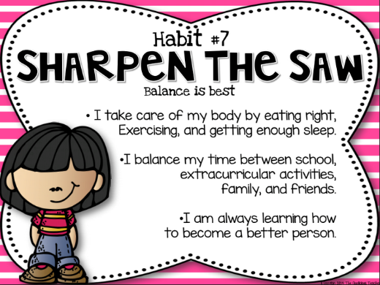
- SHARPEN THE SAW
What a great time we all had on Friday during our Sharpen the Saw time! Students were able to choose the class that they wanted to attend. The whole staff planned special activities for our kids. A BIG SHOUT OUT to Mrs. Christi Hardy and Mrs. Kristy Cole for helping out during this time. Mrs. Christi had a tea party for some of our 1st grade students and Mrs. Kristy helped with the Handy Hearts Club.

- PARENT-TEACHER CONFERENCES
Please join us on Monday, November 14th from 3:30-6:30 for our Parent-Teacher Conferences. You will be able to pick up your child’s Progress Report. He/She will have another 4 ½ weeks until the nine weeks ends. During this night, you will also be able to participate in one of our Parents Sharpen the Saw activities. These are activities that you can do with your child. Our PTSO will also be meeting at 5:30 in the Library.

- SCIENCE FAIR
Our annual Science Fair will be held on Monday and Tuesday of Thanksgiving week. Students will need to turn in their Science Form on Friday, November 18th to ensure their spot. Science boards and material will need to be at the school on Monday the 21st. Judges will score all science fair projects on Monday. We will have our Science Awards Program on Tuesday, November 22nd at 1:30 in the gym. Please feel free to join us as we hand our ribbons to our students.

Fulton County Athletics
Winter Schedule 2016-2017

Date MS/HS Opponent Place Concessions
Mon 11/7 MS JVB/G/B Hickman Co. Home @ 5:00 HS Girls BBall
Thurs 11/10 MS JVB/G/B Lake Co. Home @ 5:00 HS Boys BBall
Tues 11/15 MS JVB/G/B Carlisle Co. Home @ 5:00 Golf/HS Cheer
Thurs 11/17 MS JVB/G/B Union City Home @ 5:00 HS Football
Mon 11/28 HS GV/BV Carroll Academy Away @6:00 ______
Tues 11/29 MS JVB/G/B Lake Road Away @ 5:00 ______
Tues 11/29 HS GJV/GV Calloway Co. Away @ 6:00 ______
Tues 11/29 HS BJV/BV Trigg Co. Home @ 6:00 MS Track
Thurs 12/1 MS G/B CCA Home @ 5:00 HS Track
Fri 12/2 HS GV/BV Hollow Rock, TN Home @6:00 MS GirlsBBall
Sat 12/3 HS GV/BV Dongola, IL Home @ 6:00 MS Boys BBall
Mon 12/5 MS JVB/G/B Carlisle Co. Away @ 5:00 ______
Mon 12/5 HS GJV/GV Trigg Co. Home @ 6:00 Volleyball
Tues 12/6 HS GV/BV CCA Home @ 6:00 Cross Country
Thurs 12/8 MS JVB/G/B So. Fulton (8th Grade) Home @ 5:00 Baseball
Mon 12/12 HS GV/BV Lake Co. Home @ 6:00 MS Cheer
Tues 12/13 HS BV/GV Calloway Co. Home @ 6:00 MS Football
Thurs 12/15 MS JVB/G/B Fulton City Away @ 5:00 ______
Thurs 12/15 HS BV Christian Fellowship Away @ 6:00 Trees & Trends Classic
Sat 12/17 HS BV Christian Fellowship Away @ TBA Trees & Trends Classic
Mon 12/19 MS JVB/G/B Murray Away @ 5:00 ______
Mon 12/19 HS BV Christian Fellowship Away @ TBA Trees & Trends Classic
Thurs 12/29 HS GV Dongola, IL Away @ TBA Dongola Christmas Tourney
Fri 12/30 HS GV Dongola, IL Away @ TBA Dongola Christmas Tourney
Mon 1/2 MS JVB/G/B Fulton City Home@5:00 HS Track
Tues 1/3 HS GJV/GV/BV Hickman Co. Home @ 4:30 Softball
Thurs 1/5 MS JVB/G/B Hickman Co. Away @ 5:00 ______
Fri 1/6 HS GV/BV Fulton City Home @ 6:00 MS Girls BBall
Sat 1/7 MS VG/VB Lake Co. Away @ 3:00 ______
Sat 1/7 HS GV/BV Lake Co. Away @ 6:00 ______
Mon 1/9 HS GV/BV Hollow Rock, TN Away @ 6:00 ______
Mon-Fri 1/9-1/13 MS DISTRICTS@FULTON CITY TBA
Thurs 1/12 HS GV/VB St. Mary Home @ 6:00 Cross Country
Fri 1/13 HS BJV/GV/BV Carlisle Co. Home @ 4:30 Baseball
14th-21st HS GV/BV All “A” Classic Away @ TBA ______
Sat 1/21 HS JVB/BV Trigg Co. Away @ 6:00 ______
Mon 1/23 HS GV/BV Mayfield Away @ 6:00 ______
Thurs 1/26 HS GV/BV Ballard Memorial Home @ 6:00 Volleyball
Fri 1/27 HS GV/BV CCA Away @ 6:00 ______
Mon 1/30 HS GV/BV Carroll Academy Home @ 5:00 MS Boys BBall
Tues 1/31 HS BJV/GV/BV Carlisle Co. Away @ 4:30 ______
Fri 2/3 HS BJV/GV/BV Hickman Co. Away @ 4:30 ______
Tues 2/7 HS BJV/BV Christian Fellowship Home 4:30 HS Girls BBall
Fri 2/10 HS GV/BV Fulton City Away @ 6:00 ______
Sat 2/11 HS BJV/BV Calloway Co. Away @ 2:00 ______

Mon 2/13 HS GV/BV Mayfield Home @ 6:00 MS Football
Tues 2/16 HS GV/BV Ballard Memorial Away @ 6:00 ______
20th-24th HS 1st District Tournament Home @ TBA
Mon 2/20 HS 1st District Tournament Home @ TBA MS Cheer
Tue 2/21 HS 1st District Tournament Home @ TBA Baseball
Thurs 2/23 HS 1st District Tournament Home @ TBA HS Football
Fri 2/24 HS 1st District Tournament Home @TBA MS Track

Fulton County Elementary/Middle School
will focus students on educational success by teaching them to cooperate,
accept responsibility, respect others, expect excellence, and
become life-long learners.

FCEMS CARES!

November 8th – No School – Election Day
November 11th – Veterans Day Program at 1:30 in our Gym
November 11th – Booster Club Fall Festival
November 14th – Parent/Teacher Conferences 3:30-6:30
November 14th – Parent Sharpen the Saw Activities 3:30-5:30
November 14th – PTSO Meeting at 5:30 in the Library
November 21st – Science Fair
November 22nd – Science Fair Awards at 1:30 in the Gym

Please volunteer to help with our fall festival!
We need your help!!

