Anchors Away Parent Bulletin
Week of Monday, March 7, 2016

PROFICIENCY, POSITIVE RELATIONSHIPS, & PILOT PRIDE

- UPCOMING EVENTS AT FCEMS
- March 8 – Report Cards Go Home
- March 9 – SBDM Meeting at 3:30
- March 10 – Agriculture Adventures (K-4 at 8:30) (5-8 after lunch)
- March 11 – Pee Wee Reese Presentation for 7th/8th Graders at 1:30
- March 11 – Spring Fling Middle School Dance for Grades 6th-8th
- March 11 – FCHS Ag Day
- March 14 – 4 Pilot Pride Day
- March 17 – School Board Meeting
- March 22 – Band Field Trip
- March 23 – 6th/7th/8th Grade GT Dissections
- March 23 – 5th Grade Challenger Field Trip
- March 24 – FC Leadership Day
- March 25 – 4-H Communications Day
- March 25 – Fulton County EHS/Preschool Registration at West Hickman Baptist Church
- March 31 – County 4-H Communications Day at FCEMS

- RENOVATIONS
Please remember to use the door located on the middle school side to enter the building after 8:00 a.m. If you have not heard yet or seen pictures on Facebook, our bleachers have been installed and our new middle school bathrooms are opened! The best part about last week was seeing the excitement on all the students’ faces as they entered the new bathrooms and saw the bleachers. It was priceless!! The construction crew has demolished the front office area and work has begun on our new security entrance. Work has also started on our elementary side bathrooms. YEAH!!!!!!!
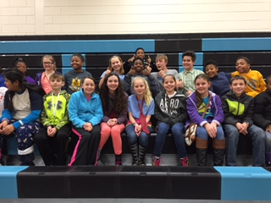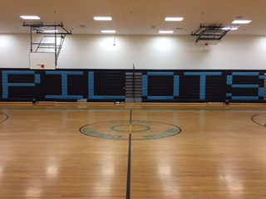
HAPPY BLEACHER FACES GO PILOTS!

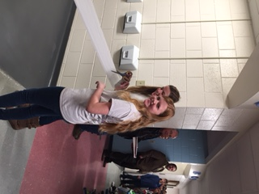 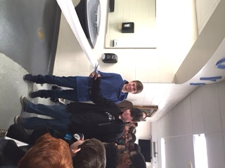 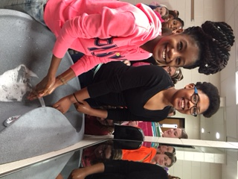 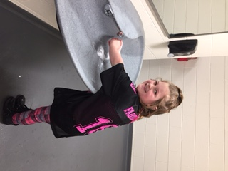OUR TOILET PAPER CUTTING CEREMONY THE WATER EVEN FEELS BETTER!

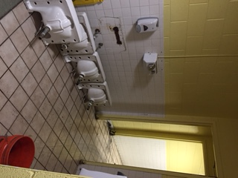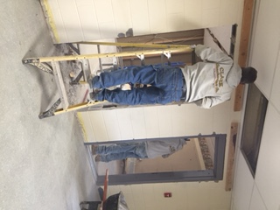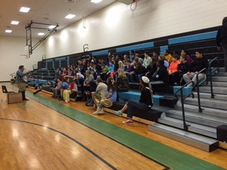
FRONT BATHROOMS AND ENTRANCE GRANDPA JONES – 1st PROGRAM

- MEDICARE PHARMACY AND HOME MEDICAL
Our Good Neighbor Pharmacy has announced a new initiative to improve child health in our community: The Good Neighbor Pharmacy Healthy Kids Free Vitamin Program. This program will offer children ages 2-12 a FREE supply of Good Neighbor Pharmacy Children’s Chewable Complete Multi-Vitamins EACH MONTH. Patients will be able to pick up a FREE bottle of vitamins every 30 days per child. To participate, ask your pharmacist for an enrollment form. For more information, contact Fran Sherrill at 270-519-5749 or call the pharmacy at 270-236-2588.

- COMMUNICATIONS DAY
Our Communications Day will be held on March 25th. Students in grades 3-8 are responsible for conducting a demonstration or a speech. Start preparing for this upcoming event!

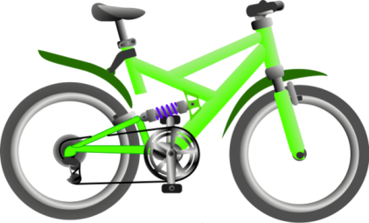
- ATTENDANCE INCENTIVE – BIKE GIVEAWAY
The Masonic Lodge donated two bikes for us to use to promote perfect attendance. All names will be put in a drawing starting from February 12th through the end of school.

- FULTON COUNTY EHS/PRESCHOOL REGISTRATION
Registration will be on March 25th from 8:00 a.m. - 3:00 p.m. at West Hickman Baptist Church in the We Believe Center. Please call the Preschool Office at 270-236-3923 ext. 5002 to set up an appointment time. Preschool is for children age 3 or 4 years old on or before August 1, 2016. Items needed to register your child:
  - Child’s Certified Birth Certificate
  - Proof of Income (2015 tax return, W-2, Proof of Child Support, SSI/Social Security, K-TAP, Student Financial Aid)
  - Child’s Social Security Card
  - Medical Card, K-CHIP, or Insurance Card
  - Custody Papers (if applicable)
  - Current Kentucky Immunization Certificate

2016 SPRING ATHLETIC SCHEDULES
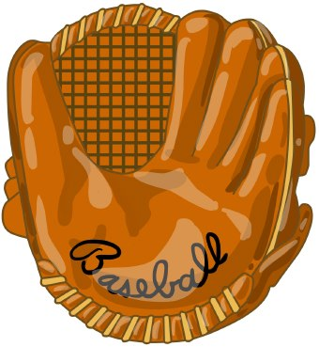
Wed 3/09 Baseball V/JV Fort Campbell HOME @ 5:30
Thu 3/10 Baseball V Community Christian Away @ 5:00
Tue 3/15 Baseball V Christian Fellowship HOME @ 5:30
Tue 3/15 HS Track @ Marshall Co
Thu 3/17 Baseball V Blytheville, AR Away @ 4:30
Thu 3/17 MS Track @ Marshall Co
Fri 3/18 Baseball V/JV South Fulton, TN Away @ 5:00
Mon 3/21 Baseball V/JV Carlisle Co HOME @ 5:30
Mon 3/21 Softball Carlisle Co HOME @ 5:00
Tue 3/22 Baseball V/JV Carlisle Co Away @ 5:30
Tue 3/22 Softball Carlisle Co Away @ 5:00
Thu 3/24 Baseball V/JV Dresden, TN Away @ 5:00
Thu 3/24 HS Track @ McCracken Co
Sat 3/26 HS Track @ Marshall Co – Invitational of South
Mon 3/28 Baseball V/JV Fort Campbell Away @ 5:30
Mon 3/28 MS Track @ Murray - All Comers
Wed 3/30 Baseball V/JV Lake Co, TN Away @ 5:00
Thu 3/31 Softball Mayfield Away @ 5:00
Fri 4/01 Baseball V/JV Lake County, TN HOME @ 5:00 Sat 4/02 HS Track @ Murray – Racer Relays
Sat 4/09 MS Track @ Dyersburg Elem - Big Kahuna

Week 4/11 Baseball V Ballard ALL-A Tourny Clinton @5:30
Week 4/11 Softball All A Classic TBA
Tue 4/12 HS Track @ Murray – Jimmy Harrell Relays only
Thu 4/14 Baseball V Cairo, IL Away @ 4:30
Thu 4/14 MS Track @ McCracken Co - All Comers
Fri 4/15 Baseball V Cairo, IL HOME @ 5:00
Sat 4/16 HS Track Paducah Tilghman - Invitational
Mon 4/18 Baseball V/JV Hickman Co HOME @ 5:00
Mon 4/18 Softball Hickman Co HOME @ 5:00
Tue 4/19 Baseball V/JV Hickman Co Away @ 5:00
Tue 4/19 Softball Hickman Co Away @ 5:00
Thu 4/21 Baseball V Christian Fellowship Away @ 5:00
Thu 4/21 Softball Christian Fellowship Away @ 5:00
Fri 4/22 Baseball V Christian Fellowship HOME @ 5:30
Fri 4/22 Softball Christian Fellowship HOME @ 5:30
Fri 4/22 HS Track @ Marshall Co – Twilight Relays
Mon 4/25 Baseball V Community Christian HOME @ 5:00
Mon 4/25 HS Track @ Ballard Co – All Comers
Thu 4/28 Baseball V/JV Dresden, TN HOME @ 5:00
Mon 5/02 Baseball V/JV South Fulton, TN HOME @ 5:00
Tue 5/03 Baseball V/JV Bradford, TN HOME @ 5:00
Thu 5/05 Softball Mayfield HOME @ 5:00
Thu 5/05 HS Track @ Union City – Rotary Relays
Mon 5/09 Baseball V Fulton City HOME @ 5:00
Mon 5/09 Softball Fulton City HOME @ 5:00
Tue 5/10 Baseball V Fulton City Away @ 5:00
Tue 5/10 Softball Fulton City Away @ 5:00
Sat 5/14 HS Track Regional 1A Championships @ Murray
Fri-Sat 5/20-21 Baseball JV Regional @ CFS & Mike Miller Field TBA
Week 5/23 Baseball Districts @ FULTON COUNTY TBA
Week 5/23 Softball Districts @ FULTON COUNTY TBA
Fri 5/27 HS Track KHSAA State Track Meet @ Lexington

REPORT CARDS GO HOME ON TUESDAY!
FCHS is having Parent-Teacher Conferences
on March 10th from 3:30-6:00.

7 Habits Quotes for Think Win-Win

“What do we live for, if it is not to make life less difficult for each other?” ~George Eliot

“You don’t have to blow out the other person’s light to let your own shine.” ~Bernard M. Baruch

“One of the biggest things that I have learned is that I don’t always have to be right.” ~Jeffrey Swartz

TEAM = Together Everyone Achieves More ~Unknown

“Alone we can do so little; together we can do so much.” ~Helen Keller

“Many hands make light work.” ~John Heywood

“Teamwork: Simply stated, it is less me and more we.” ~Unknown

Fulton County Elementary/Middle School
will focus students on educational success by teaching them to cooperate,
accept responsibility, respect others, expect excellence, and
become life-long learners.

FCEMS CARES!

