Anchors Away Parent Bulletin
Week of Monday, November 9, 2015

PROFICIENCY, POSITIVE RELATIONSHIPS, & PILOT PRIDE

- UPCOMING EVENTS AT FCEMS
- November 9 – FCMS vs. Hickman County AWAY
- November 10 – Progress Reports Go Home
- November 10 – Academic Meet at Fulton City
- November 11 – Veteran’s Day Program at 1:30 in the FCEMS Gym
- November 12 – FCMS vs CCA AWAY
- November 13 – Health Fair for Grades K-5th
- November 14 – Miss FCHS
- November 16 – Career Fair Grades 5-8 from 8:30-12:00
- November 17 – Academic Meet at Hickman County
- November 17 – FCMS vs. Carlisle HOME
- November 19 – School Board Meeting in FCEMS Library
- November 23 – Science Fair
- November 23 – GT Field Trip
- November 24 – Science Fair Awards Program at 2:00 in Gym
- November 25-27 – Thanksgiving Break
- November 30 – FCHS vs. Trigg/Murray HOME

- THANKS SO MUCH!!!!
A BIG THANKS goes out to our Cross Country Coaches: Rachel Cronin Netz and Jamie Maddie for a successful season. Our team represented us with Pilot Pride this past weekend. Many of our runners ran their personal best time at the state meet. Way to go, Fulton County!!
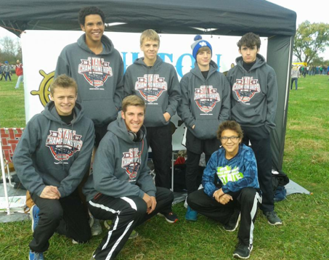
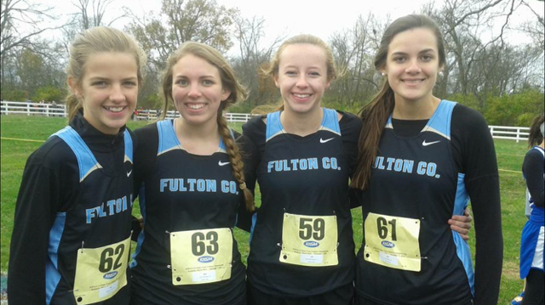

- VETERANS DAY PROGRAM
Please join us on Wednesday, November 11th as we remember our Veterans who have and are serving our country. We will have a special program in our gym at 1:30 p.m. We would love to have the community involved in this program.

- FLU SHOTS
The Purchase District Health Department will be giving FLU SHOTS at the school on November 9th and 19th for those who have turned in their paperwork.

- ACADEMIC TEAM SCHEDULE

DATE | HOST (TEAM 1) | TEAM 2 | TEAM 3
Tuesday, Nov. 10 | Fulton City | Fulton County | Carlisle County
Tuesday, Nov. 17 | Hickman County | Fulton County

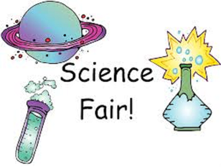
- SCIENCE FAIR PROJECTS
Our students will be having our Annual Science Fair on Monday, November 23rd. Students will need to set their projects up that morning. We will have our Science Fair Awards Program on Tuesday, November 24th at 2:00 p.m.

Fulton County Athletics

DATE SPORT RIVAL LOCATION/TIME CONCESSIONS
Mon 11/09 MS B 7b8g8b Hickman Co Away @ 5:00 --
Thu 11/12 MS B 8g8b CCA Away @ 5:00 --
Tue 11/17 MS B 7b8g8b Carlisle Co HOME @ 5:00 HS GIRLS BBALL
Mon 11/30 HS B GV Trigg Co HOME @ 6:00 MS CHEER *
Mon 11/30 HS B BV Murray HOME @ 7:30 MS CHEER *
Tue 12/01 HS B GV/BV Joppa, IL Away @ 6:00 --
Thu 12/03 MS B 7b8g8b Fulton City Away @ 5:00 --
Mon 12/07 HS B GV/BV Peabody, Trenton, TN Away @ 6:00 --
Thu 12/10 HS B GV/BV Marshall Co Away @ 6:00 --
Sat 12/12 MS B 8g8b Lake Co, TN HOME @ 3:00 HS TRACK
Sat 12/12 HS B GV/BV Lake Co, TN HOME @ 6:00 MS TRACK
Mon 12/14 MS B 7b8b Reidland Away @ 5:00 --
Tue 12/15 HS B BJV/BV Calloway Co Away @ 6:00 --
12/17 – 12/21 HS B BV Chr Fellowship Tourny TBA
Tue 12/29 HS B GV Trigg New Years Tourny TBA
Mon 1/04 MS B 7g8g8b Carlisle Co Away @ 5:00 --
Tue 1/05 HS B BJV/GV/BV Hickman Co Away @ 5:00 --
Thu 1/07 MS B 7b8b Reidland HOME @ 5:00 HS FOOTBALL
Fri 1/08 HS B GV/BV Fulton City Away @ 6:00 --
Sat 1/09 HS B GV/BV Marshall Co HOME @ 6:00 MS FOOTBALL
Mon 1/11 MS B 7g8g8b Hickman Co(8th Gr Night) HOME @ 5:00 VOLLEYBALL
Tue 1/12 HS B BJV/BV McCracken Co HOME @ 6:00 SOFTBALL
Fri 1/15 HS B BJV/GV/BV Carlisle Co Away @ 5:00 --
1/16 – 1/23 HS B GV/BV 1st Region All ‘A’ Classic TBA

Tue 1/19 MS B 7g8g8b Fulton City HOME @ 5:00 BASEBALL
Thu 1/21 MS B 7g8g8b BlackOak@Hornbeak Away @ 5:00 --
Mon 1/25 HS B BJV/GV/BV Mayfield Away @ 5:00 --
Thu 1/28 HS B GV/BV Ballard Memorial Away @ 6:00 --
Fri 1/29 HS B GV/BV CCA* HOME @ 6:00 MS GIRLS BBALL
Tue 2/02 HS B BJV/GV/BV Carlisle Co HOME @ 5:00 MS BOYS BBALL
Fri 2/05 HS B BJV/GV/BV Hickman Co HOME @ 4:30 MS CHEER
Sat 2/06 HS B GV/BV Lake Co, TN Away @ 6:00 --
Tue 2/09 HS B GV/BV CFS HOME @ 6:00 MS TRACK
Fri 2/12 HS B GV/BV Fulton City HOME @ 6:00 GOLF & CROSS COUNTRY
Mon 2/15 HS B GV/BV Mayfield HOME @ 6:00 MS FOOTBALL
Thu 2/18 HS B GV/BV Ballard Memorial HOME @ 6:00 SOFTBALL
Fri 2/19 HS B GV/BV Graves Co Away @ 6:00 --
2/22 – 2/26 HS B GV/BV 1st District Tourny TBA

-Progress Reports will come home on Tuesday, November 10th!
-Veteran’s Day Program will be on Wednesday, November 11th!
-Science Fair is coming up . . . start working on your project!

Fulton County Elementary/Middle School
will focus students on educational success by teaching them to cooperate,
accept responsibility, respect others, expect excellence, and
become life-long learners.

FCEMS CARES!

